

XXXXXXX

Chitimba ………

Dear Sir or Madam,

With this letter, we want to confirm the following.

The persons with the details below will be staying as our guests at Chitimba camp, PO box 63,
Chitimba, Rumphi District, Malawi from XXXXXX to XXXXXX for three nights while in Malawi. This person will be traveling with the tour operator Intrepid Travel.

Guest Name: XXXXXX

Guest Surname: XXXXXXX

Date of birth: XXXXXXX

Nationality: XXXXXXX

Passport Number: XXXXXX

Passport expiration date: XXXXXXX

We hope that we informed you enough with this document. If there are any questions, do not hesitate to contact us.

Kind Regards,
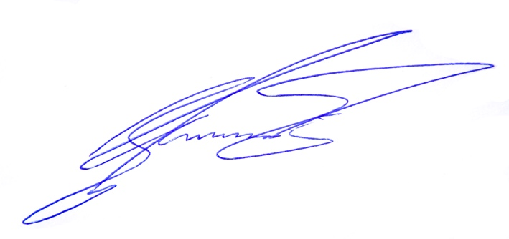
Ed Peeters and Carmen Geurtjens
(managing directors Chitimba camp)

Chitimba Camp Tel: (00)265( 0)888387116
PO Box 63, Chitimba E-mail:camp@chitimba.com
Rumphi district, Malawi Website: www.chitimba.com

