XXXXXXX
To whom it may concern,
RE: Malawi Invitation Letter
This letter serves to confirm that the below client is booked and confirmed on the following tour and that full payment has been received by the agent.
Client’s Name | XXXXXXX
Client’s Nationality | XXXXXXX
Client’s Passport Number | XXXXXXX
Booking Confirmation number | XXXXXXX
Trip Name and departure date: | Trip name: XXXXXXX  Departure Code: TAA + vertrekdatum Nederland  Trip Start Date: XXXXXXX
Date of entry into Malawi | XXXXXXX
S accommodation booked and confirmed at: | Chitimba Camp  P.O. Box 63 Chitimba  Rumphi District, Malawi  Tel: +(265) - (0)888387116  E-mail: camp@chitimba.com  Kande Beach Resort,  P.O. Box 22 Kande,  NKHATA BAY SOUTH  MALAWI
Date of exit from Malawi | XXXXXXX
Please do not hesitate to contact me for more information or further assistance.
Kind regards,
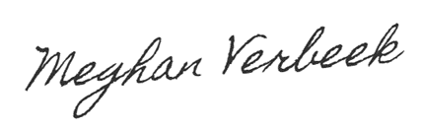
Meghan Verbeek
Product Category Manager - Wildlife

Intrepid DMC – East Africa
Tel: +254 758 555 550 / +254 758 555 556
Add: Kombe Road (Off Bogani Rad) Karen, Nairobi, Kenya
www.intrepidtravel.com

